Assignment 2
Data Quality Assessment & Preprocessing
ARTI308 - Machine Learning- Fedaa Alsabea- 2230003675

Task 1 Identify data quality issues in the dataset:
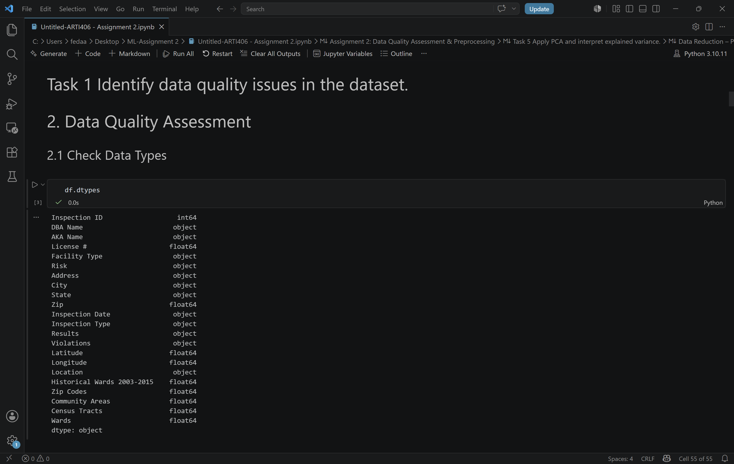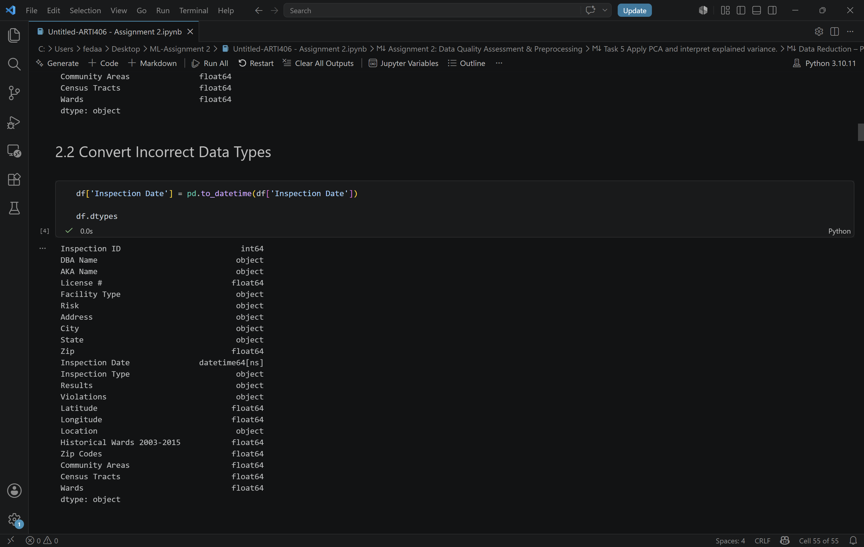
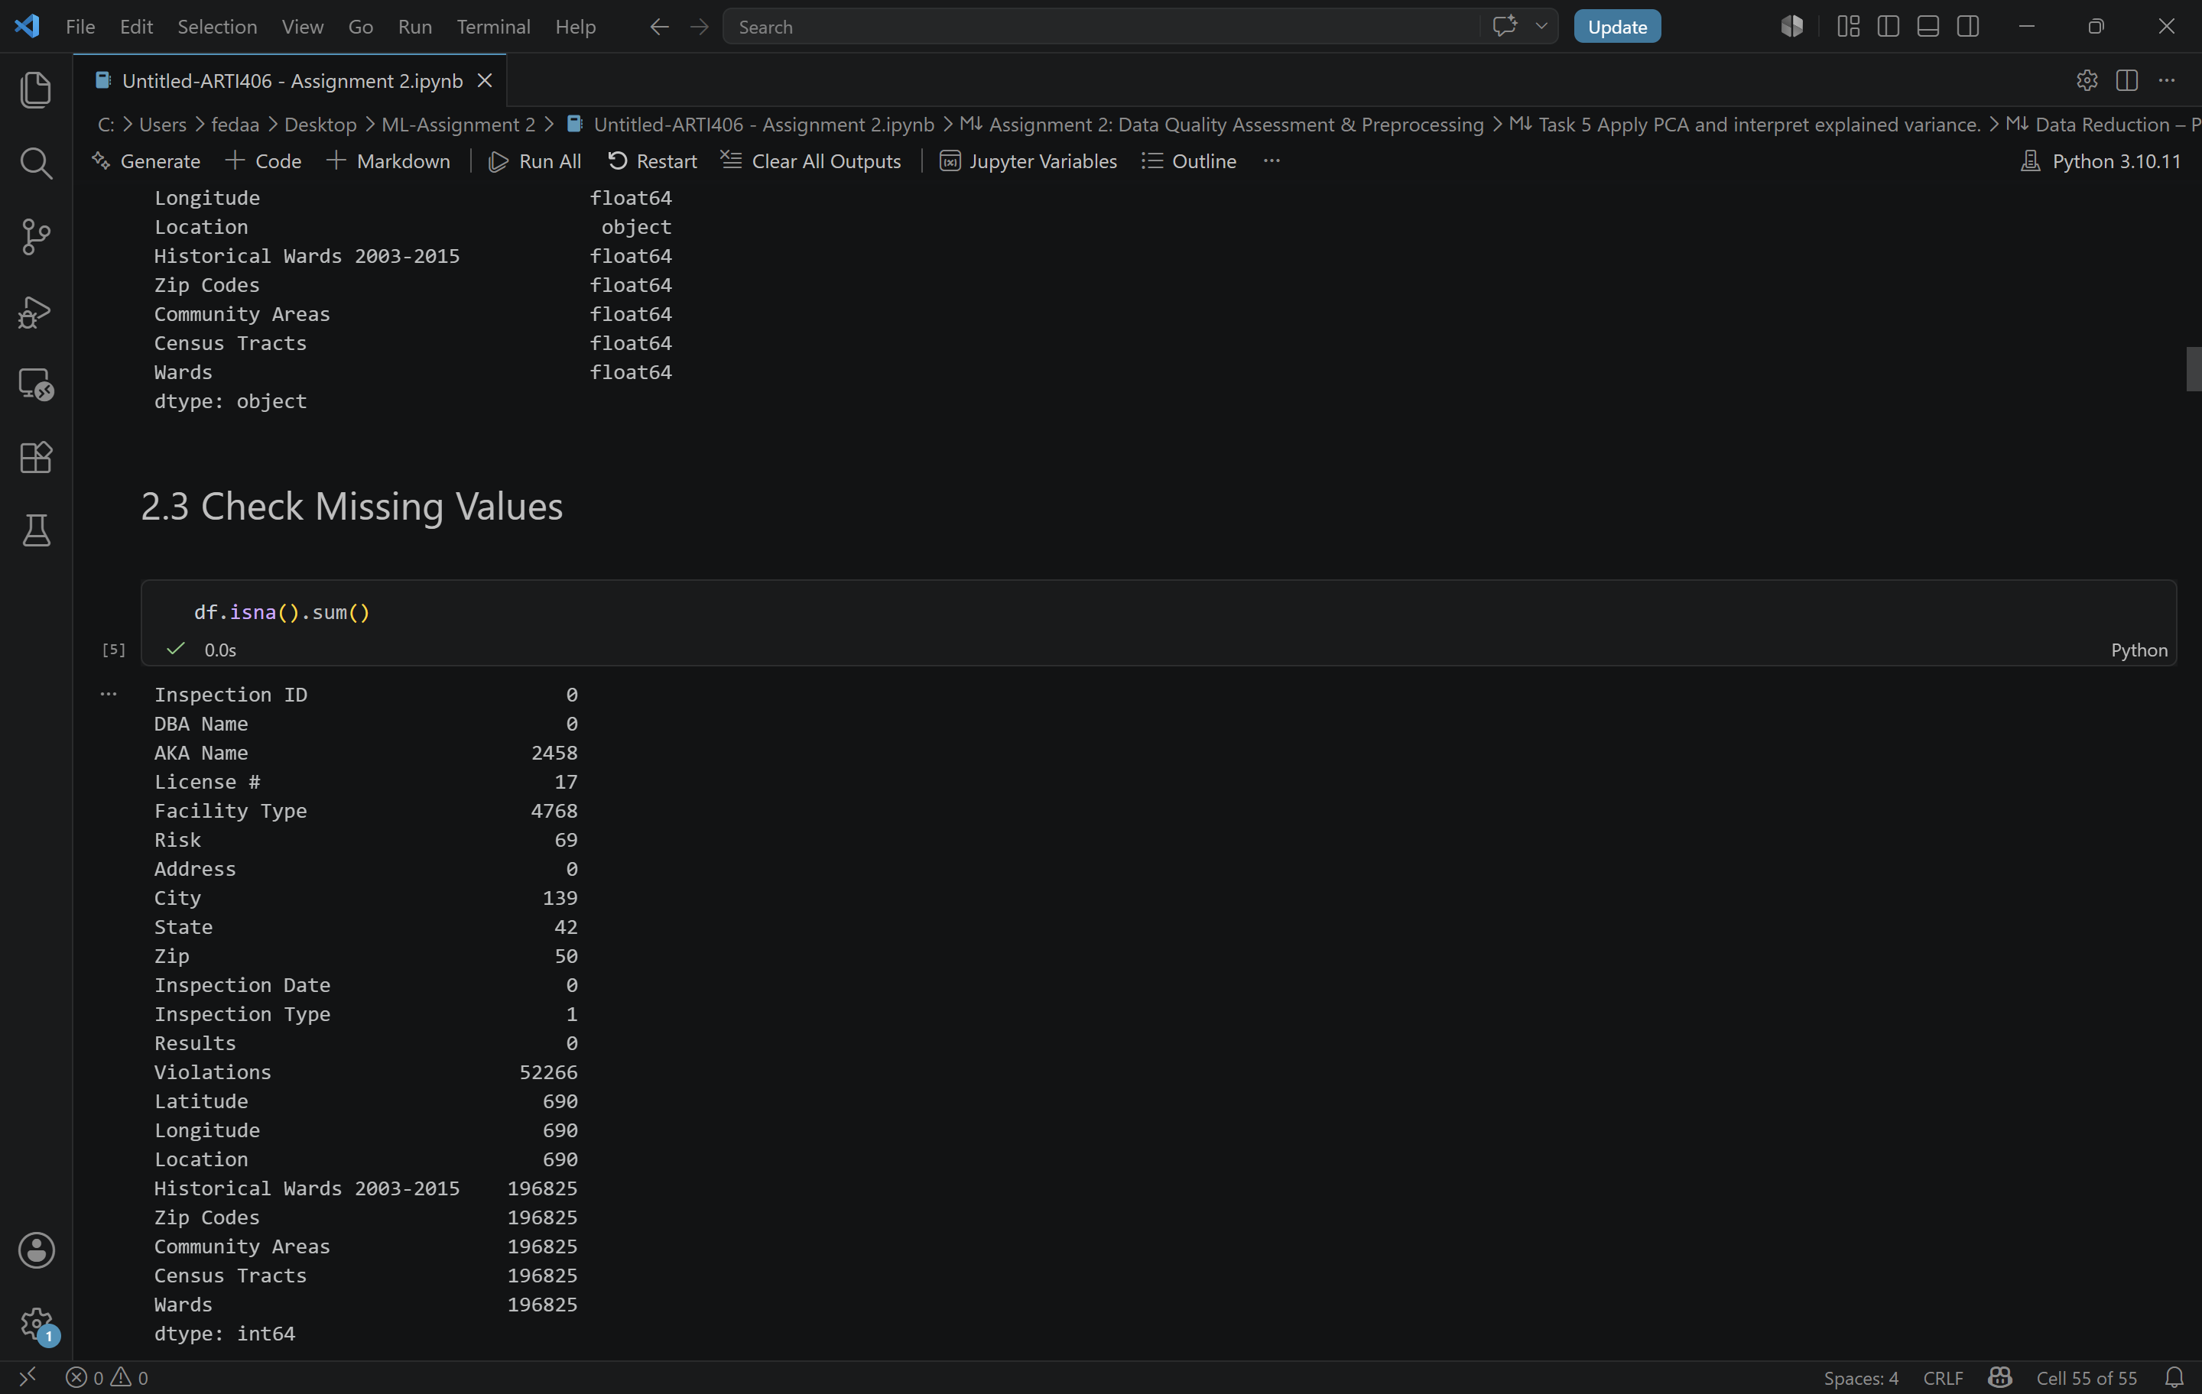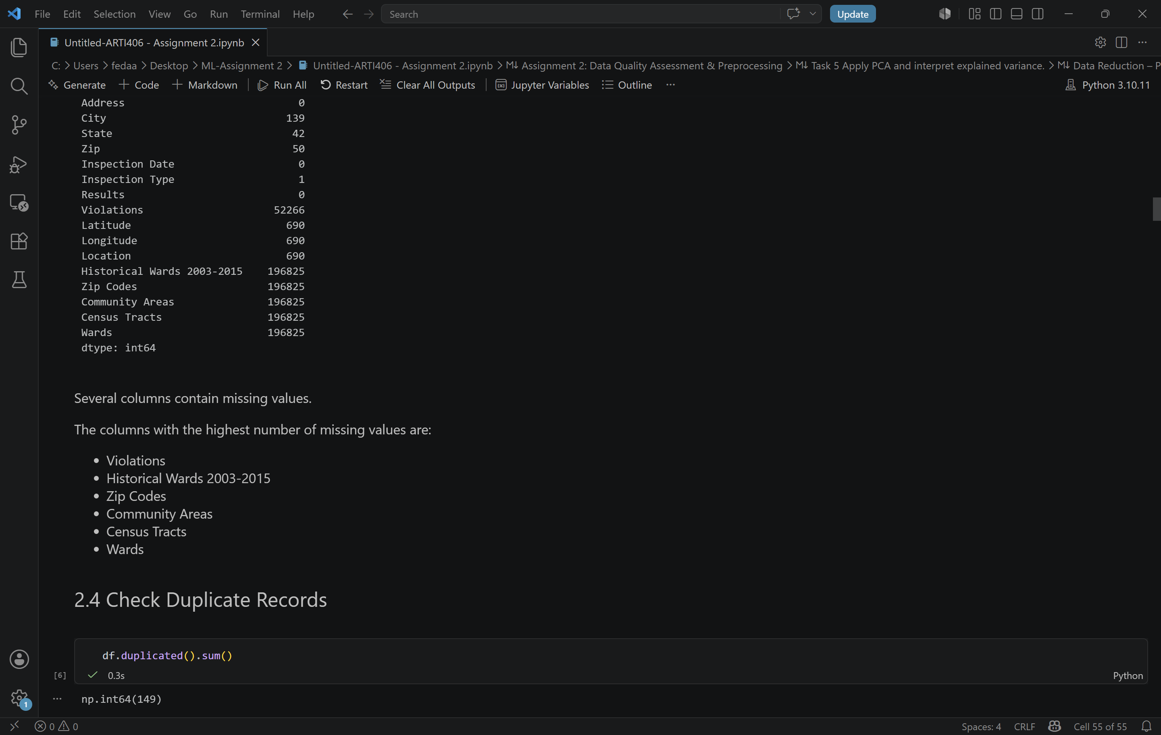

The dataset was checked for data quality issues by examining data types, missing values, and duplicate records.
First, the data types were checked. The Inspection Date column was originally stored as an object, so it was converted to datetime format.
Then, missing values were identified. Several columns contained missing values, especially Violations, Historical Wards 2003-2015, Zip Codes, Community Areas, Census Tracts, and Wards.
Finally, duplicate records were checked. The dataset contained 149 duplicate records.

Task 2 Apply one missing value strategy and explain why:

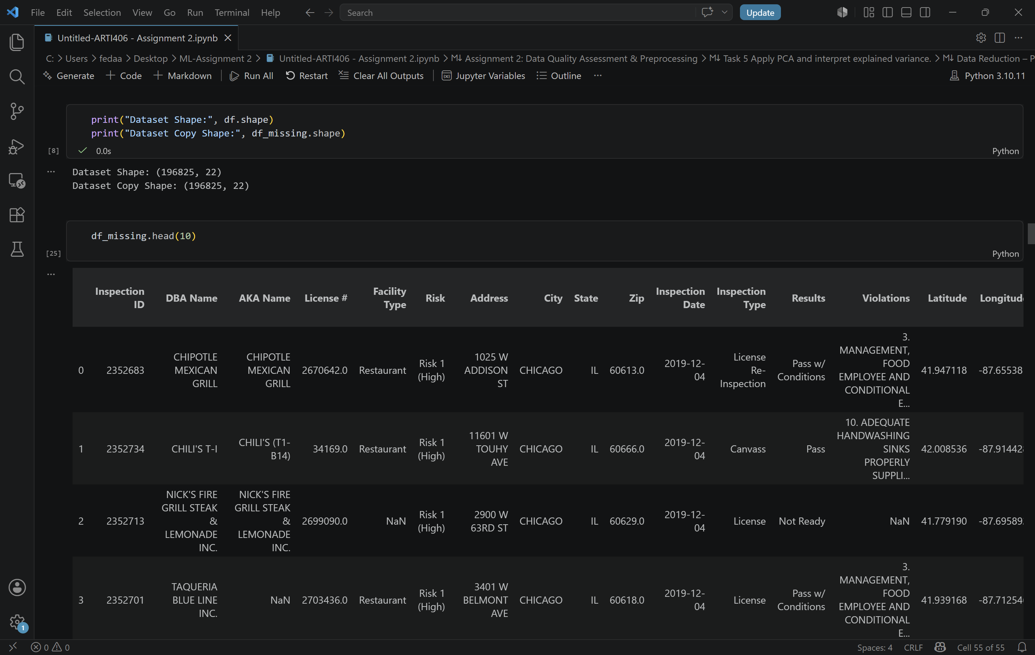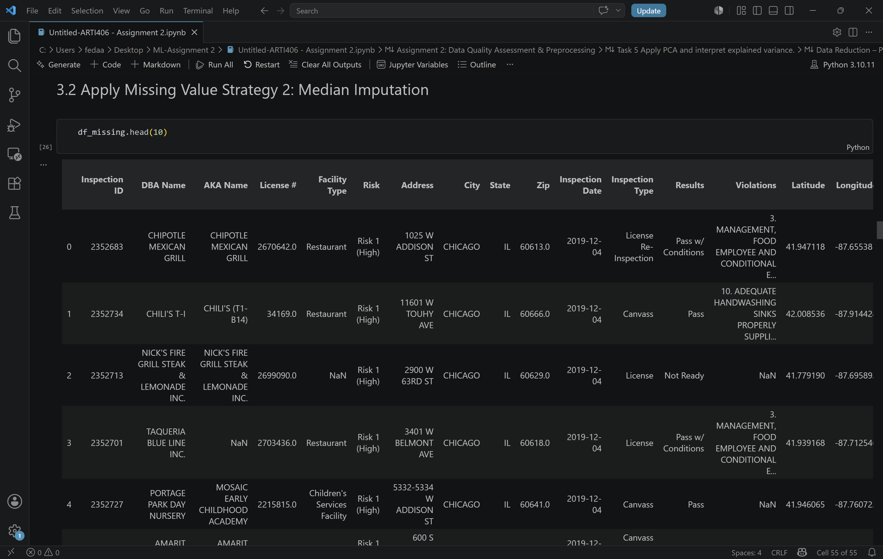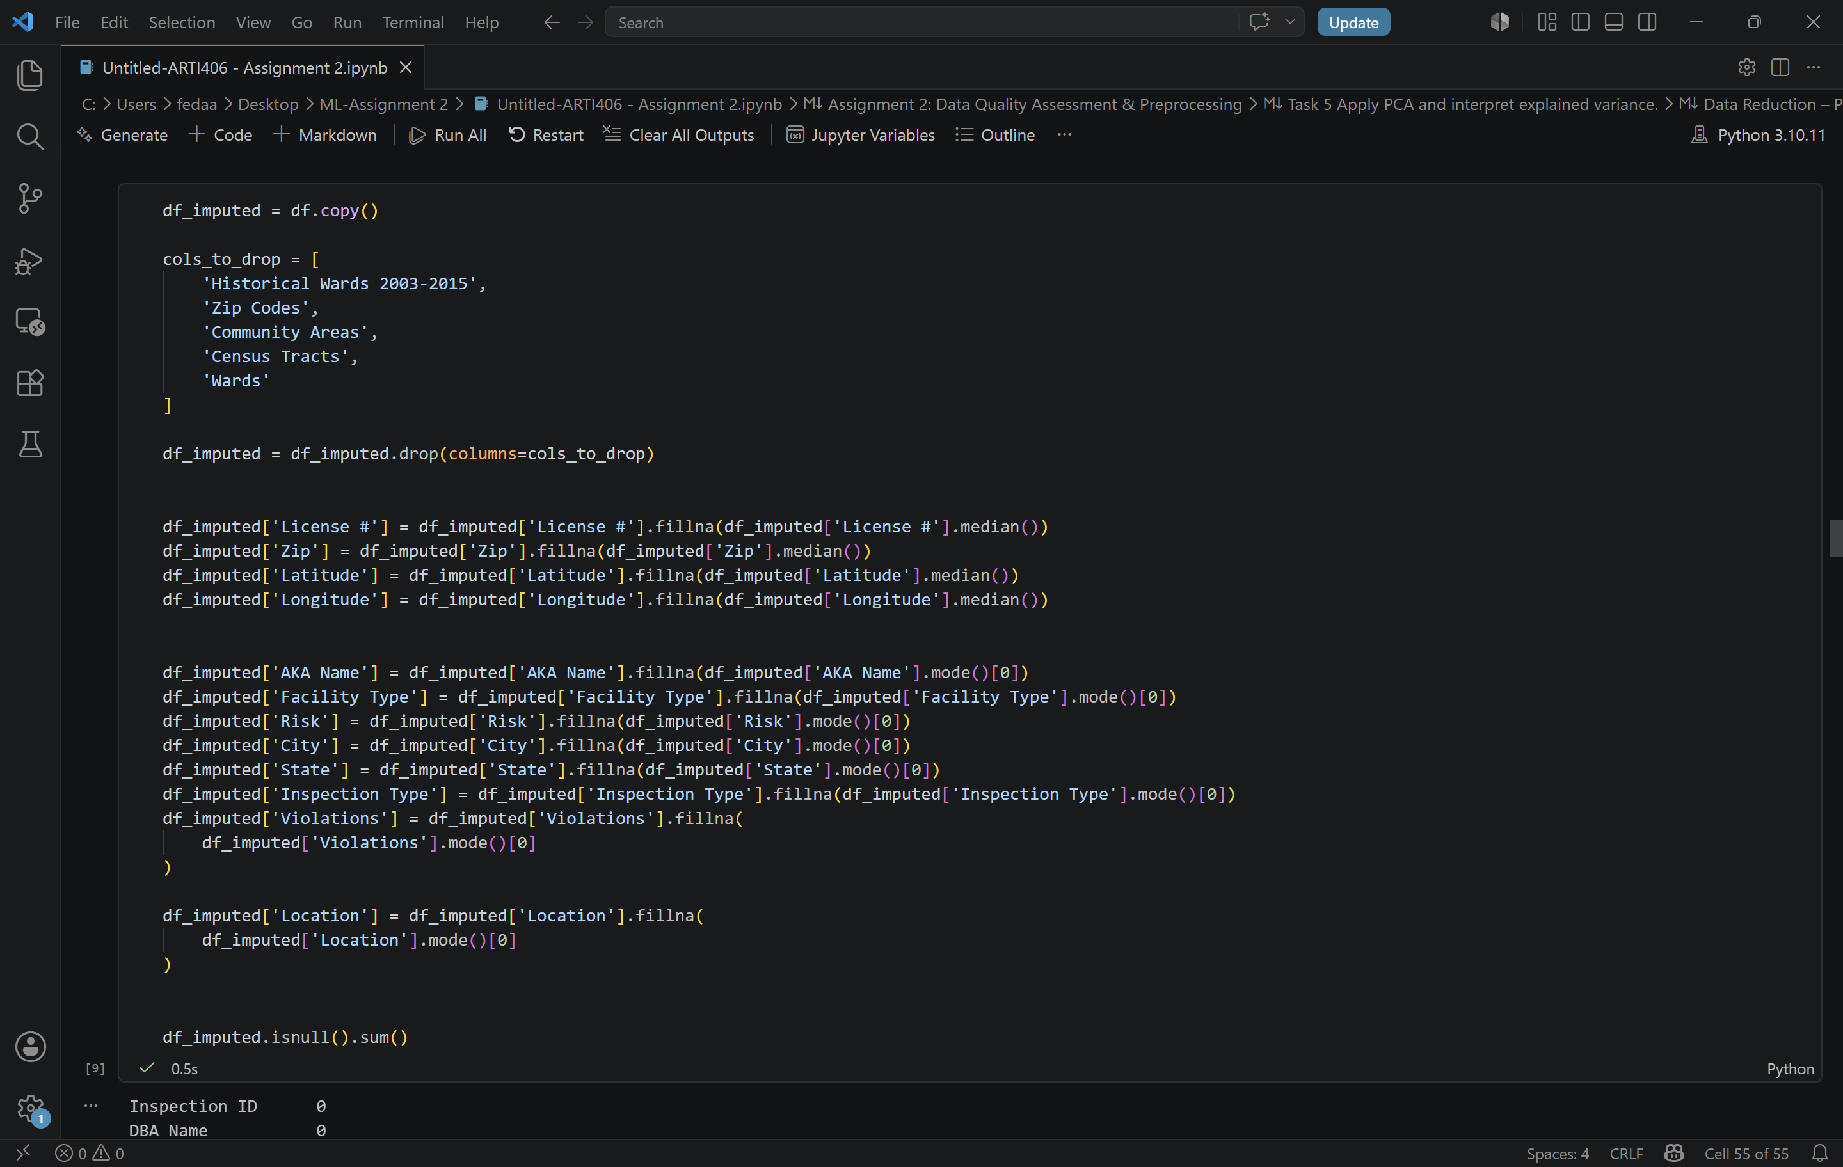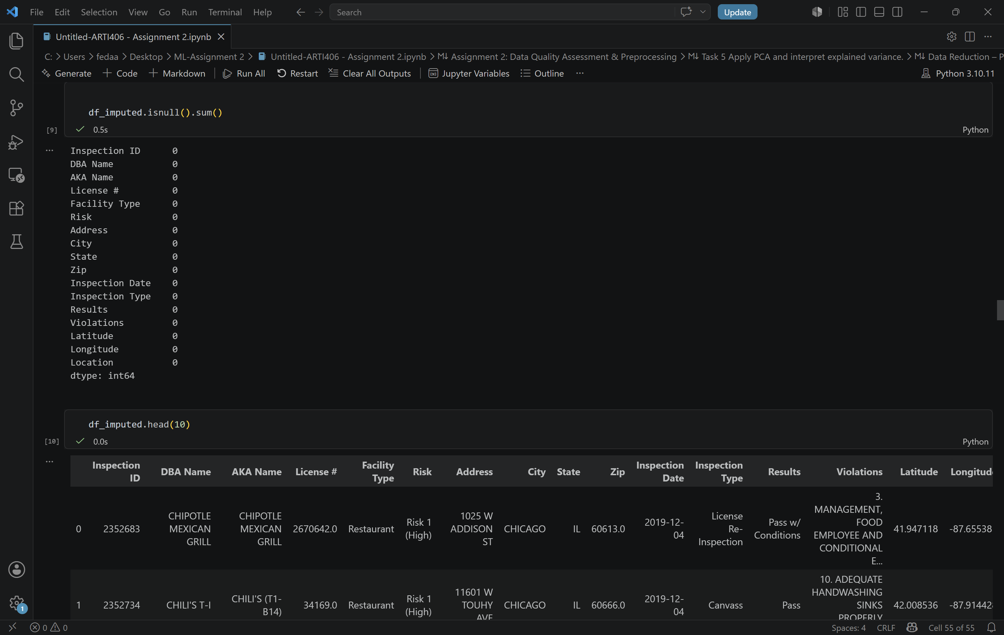

The dataset contained missing values in several columns. A missing value analysis was performed to identify the affected features.
To handle missing values, a median imputation strategy was applied to numerical columns such as License #, Zip, Latitude, and Longitude. The median was selected because it is less sensitive to extreme values and provides a robust estimate of the center of the data.
For categorical columns such as AKA Name, Facility Type, Risk, City, State, Inspection Type, and Location, the mode (most frequent value) was used to replace missing entries.
Some columns contained a very large number of missing values, including Historical Wards 2003-2015, Zip Codes, Community Areas, Census Tracts, and Wards. These columns were removed because most of their values were missing and they would contribute little useful information to the analysis.
After applying the imputation strategy and removing highly incomplete columns, no missing values remained in the dataset.

Reason for Choosing Median Strategy:
Median imputation was selected because numerical variables may contain skewed distributions and outliers. Unlike the mean, the median is not heavily affected by extreme values, making it a more reliable replacement for missing numerical data.

Task 3 Detect and handle outliers using IQR:
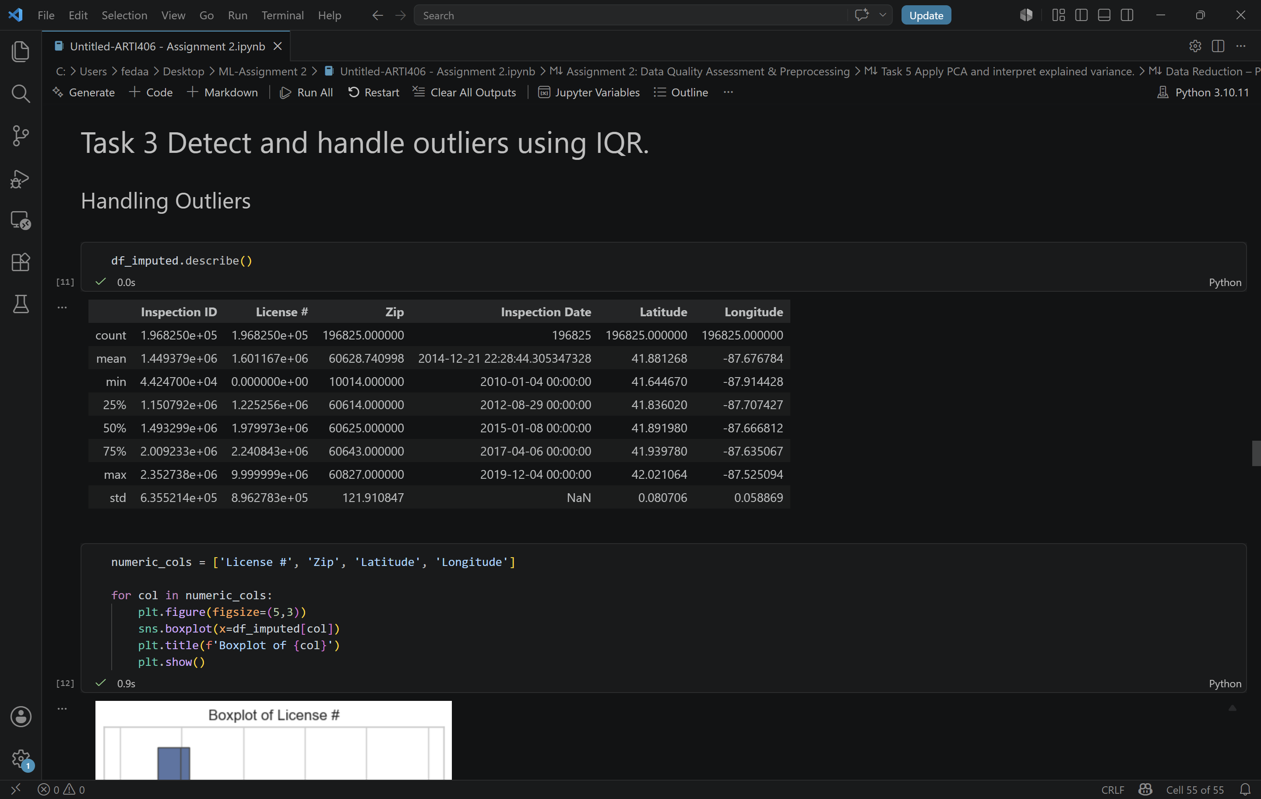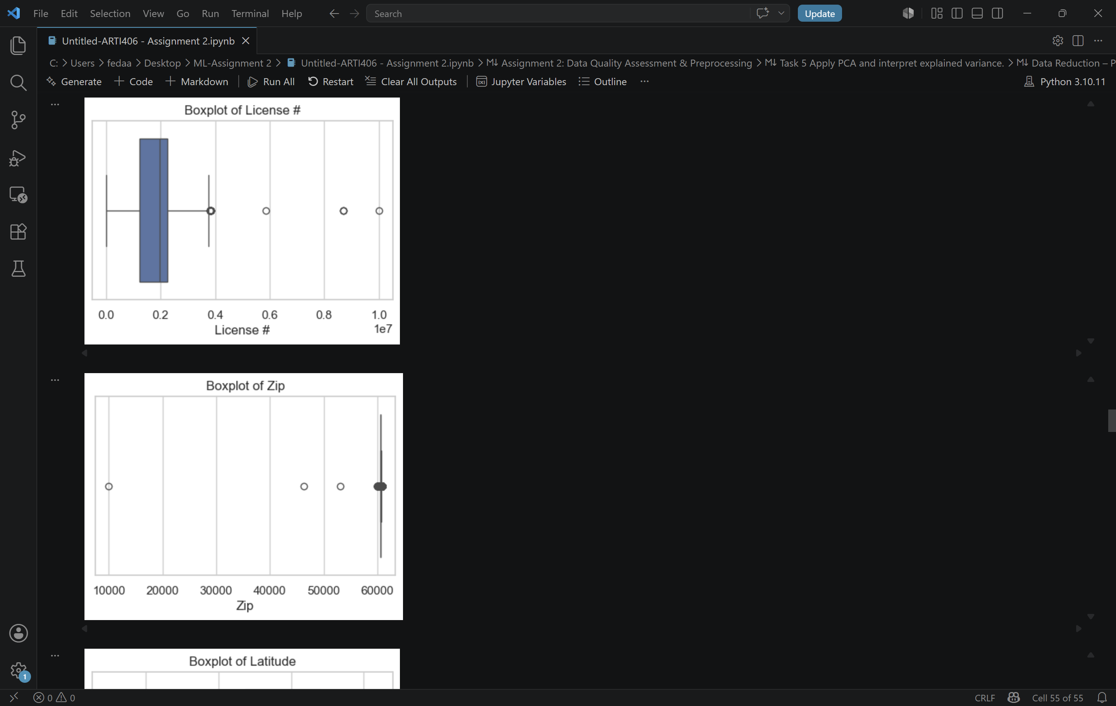

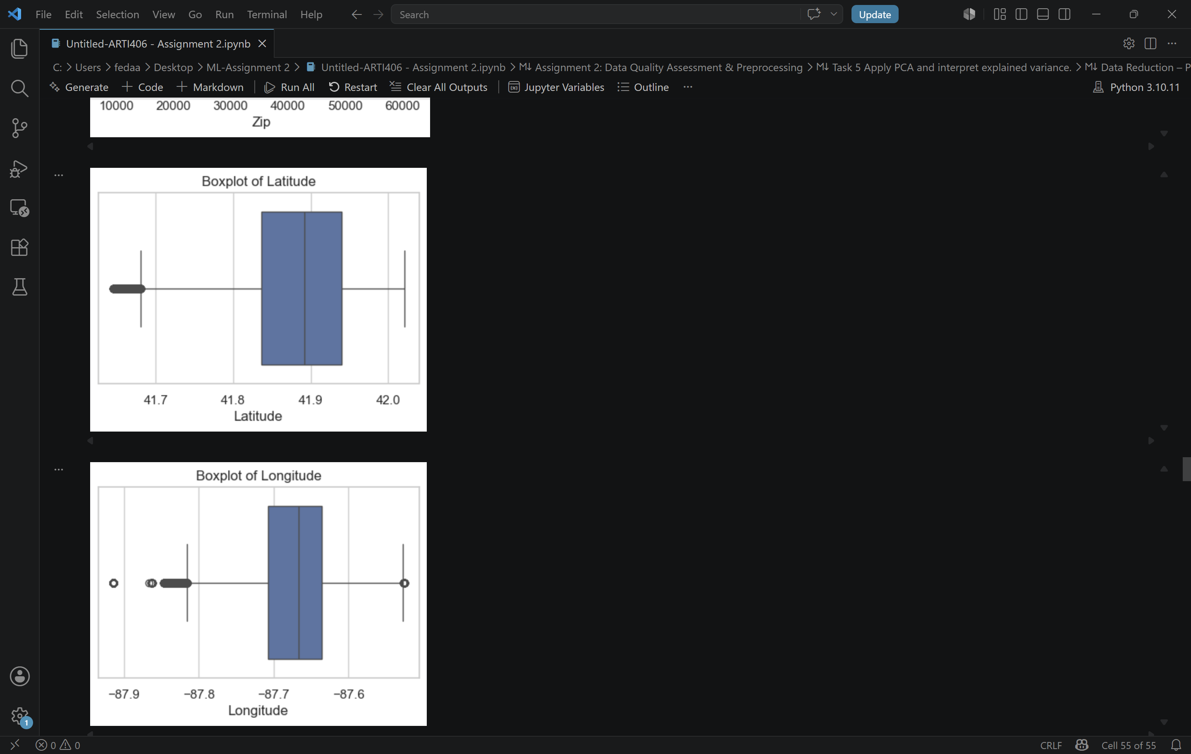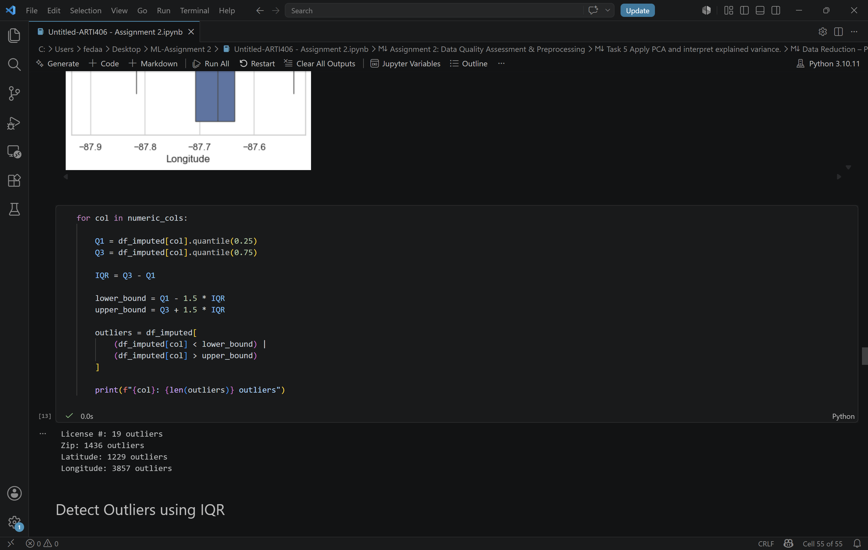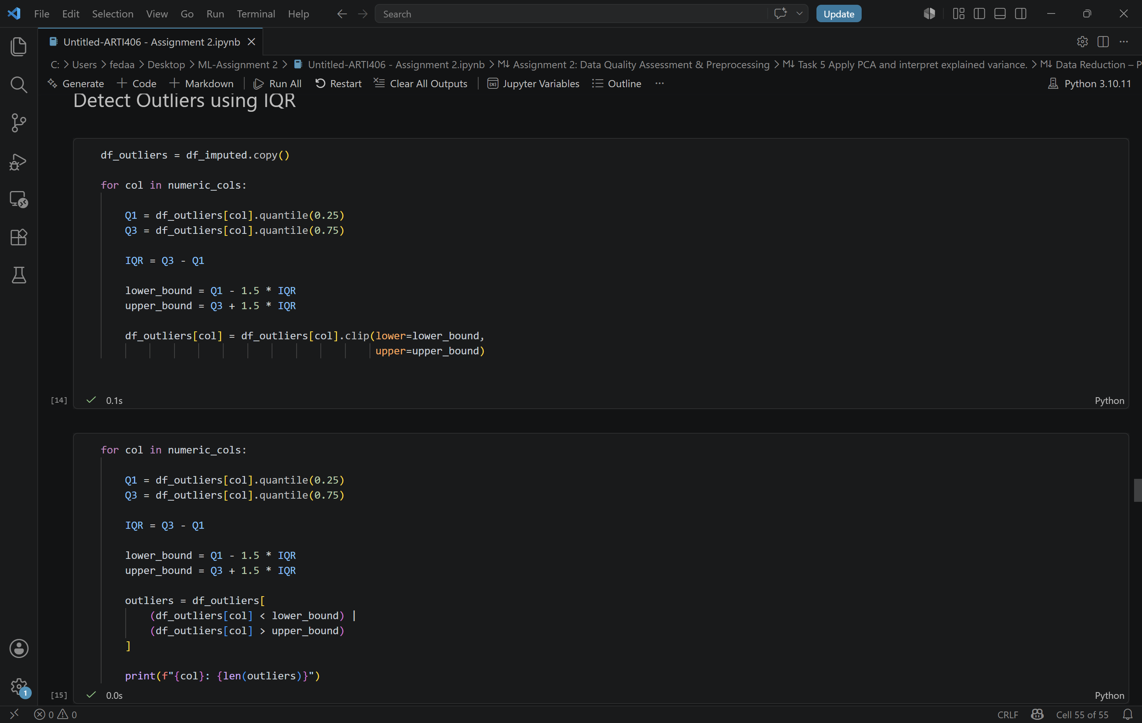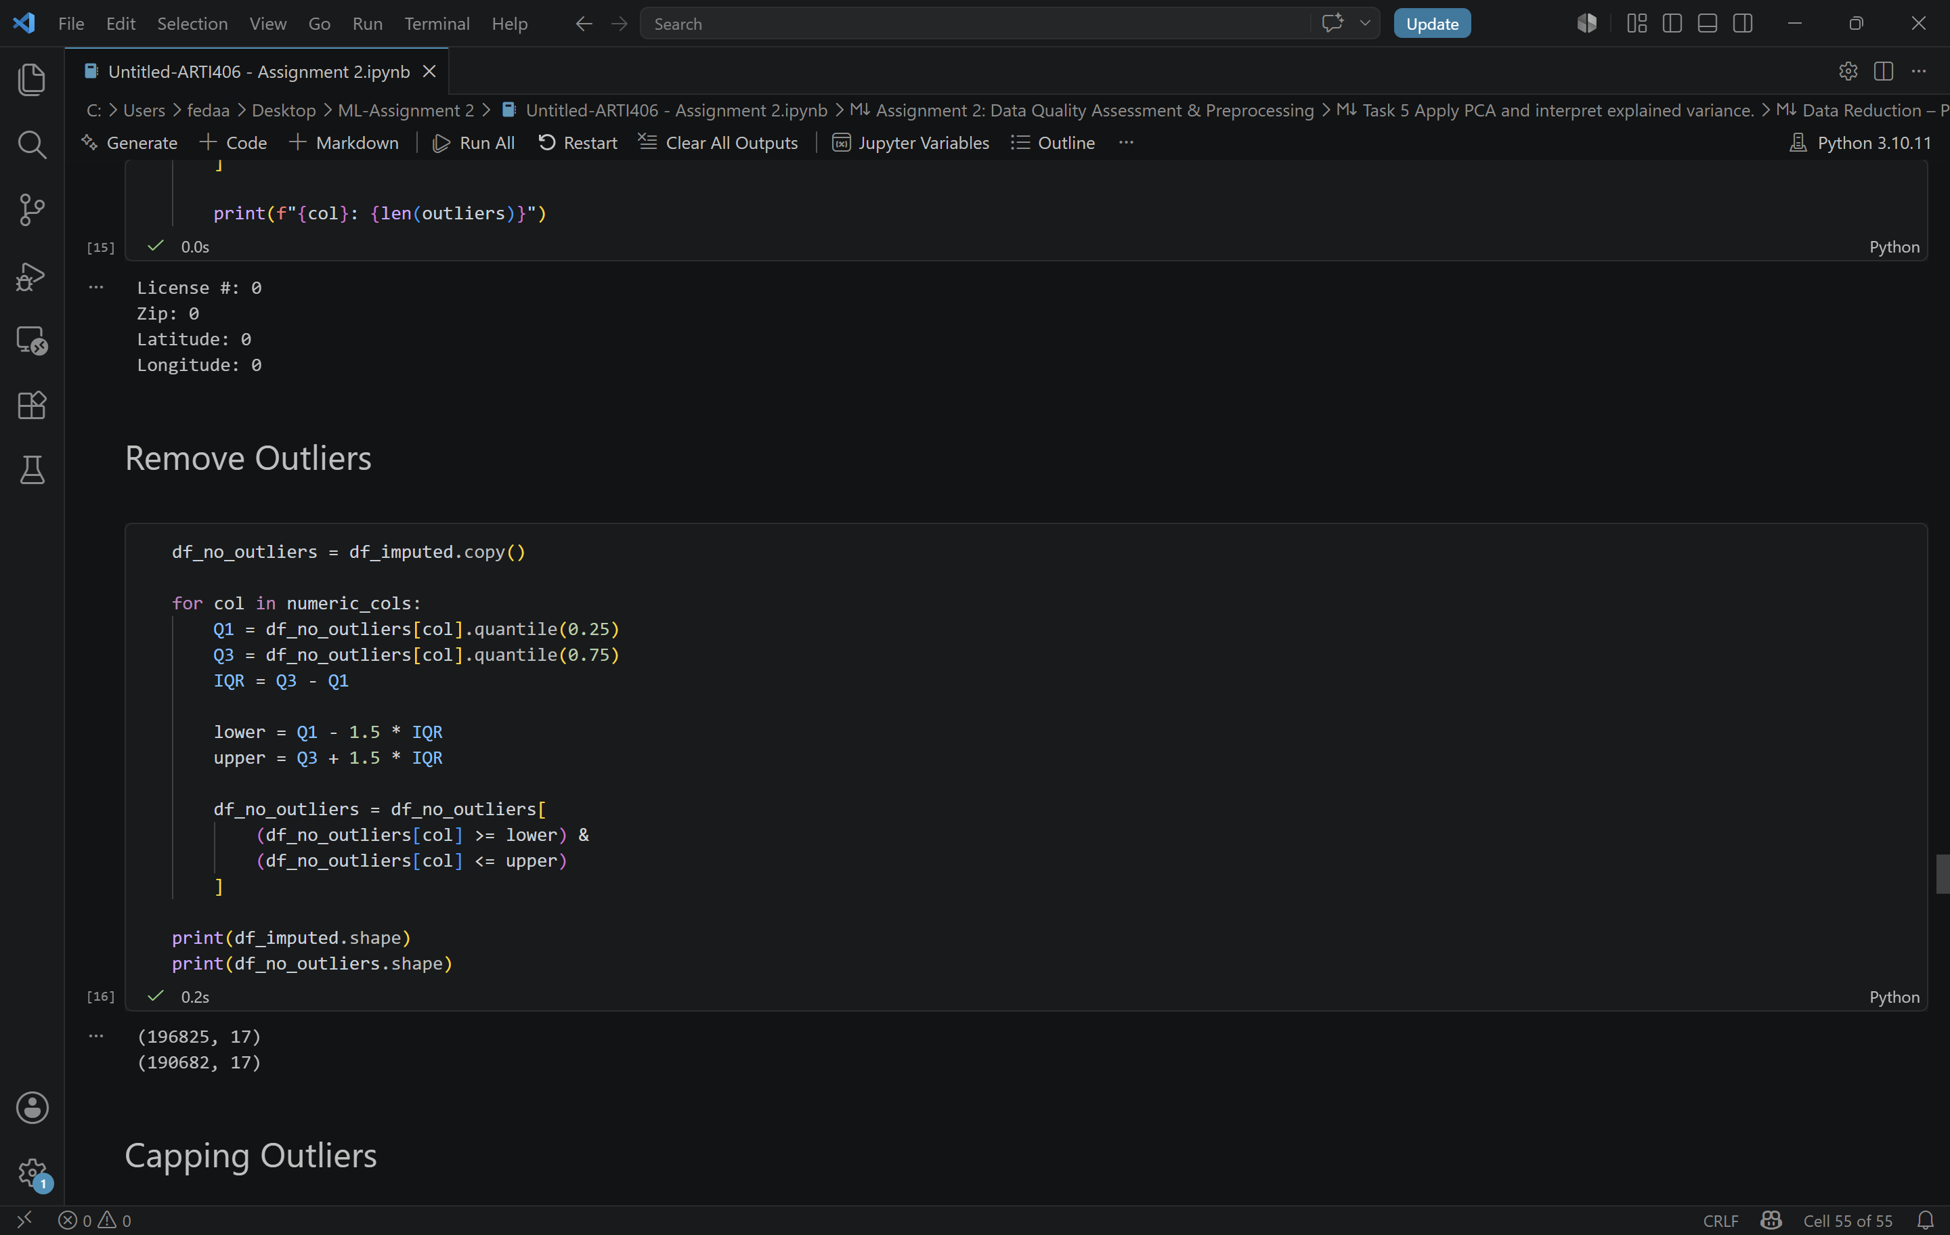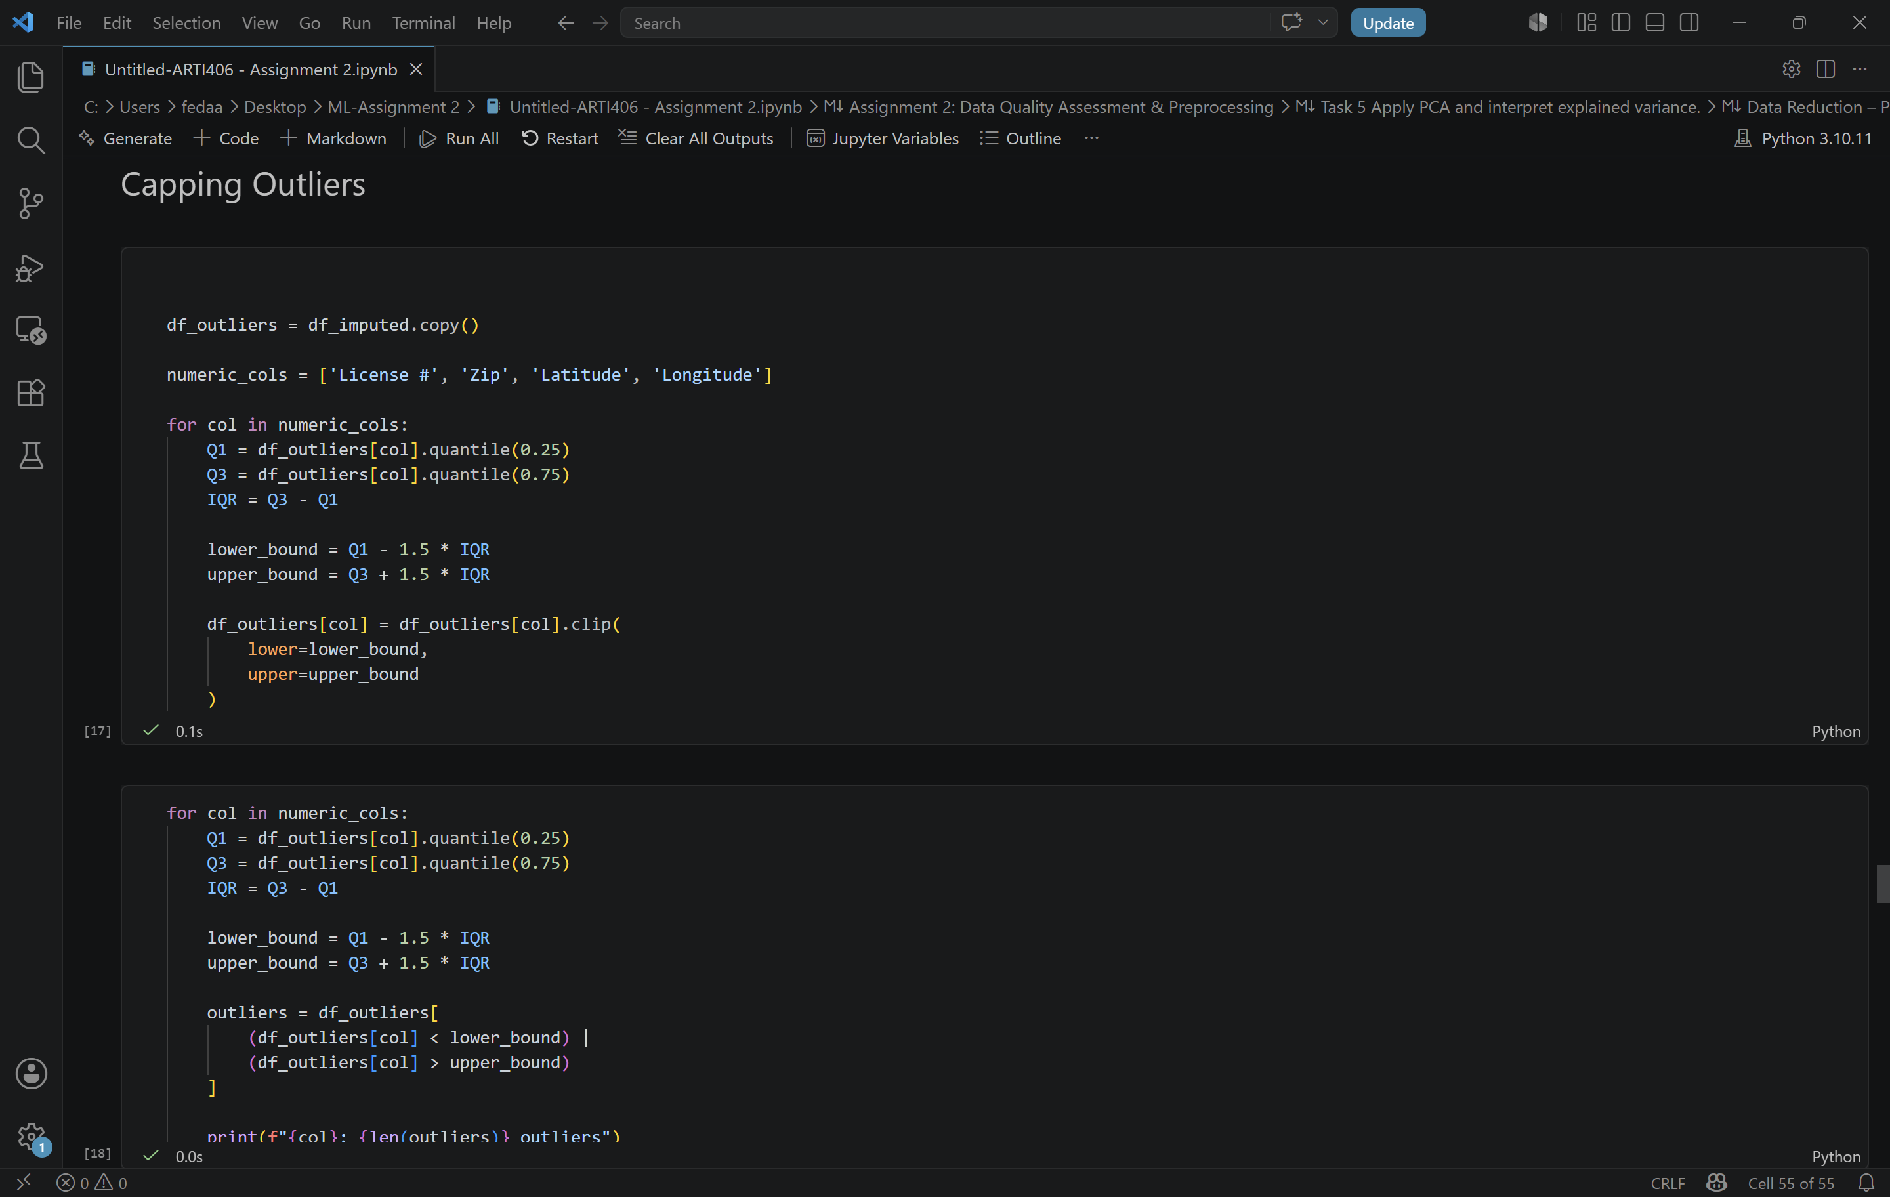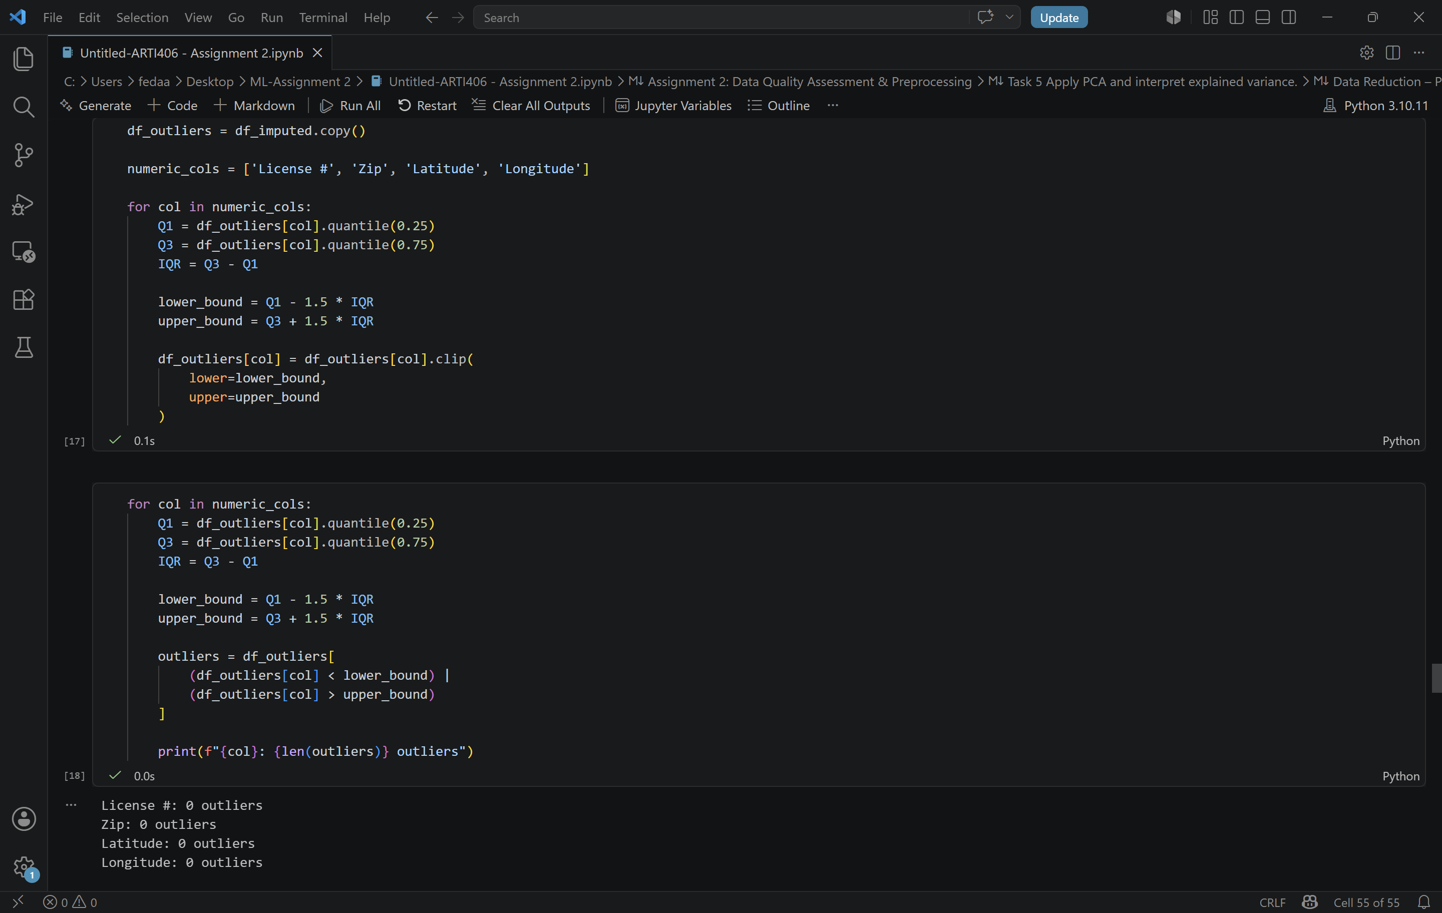

Outliers were detected using the Interquartile Range (IQR) method. The first quartile (Q1), third quartile (Q3), and IQR were calculated for each numerical feature.
Any value below Q1 − 1.5 × IQR or above Q3 + 1.5 × IQR was considered an outlier.
Boxplots were used to visualize the distribution of the numerical features and confirm the presence of extreme values.
Detected Outliers:
• License #: 19
• Zip: 1436
• Latitude: 1229
• Longitude: 3857
Instead of removing records, outliers were handled using IQR-based capping. Values below the lower bound were replaced with the lower boundary value, while values above the upper bound were replaced with the upper boundary value.
This approach preserves all observations while reducing the influence of extreme values.
After applying IQR-based capping, all detected outliers were successfully handled, and no outliers remained in the selected numerical features.

Task 4 Normalize numerical features using both Min-Max and Z-score:
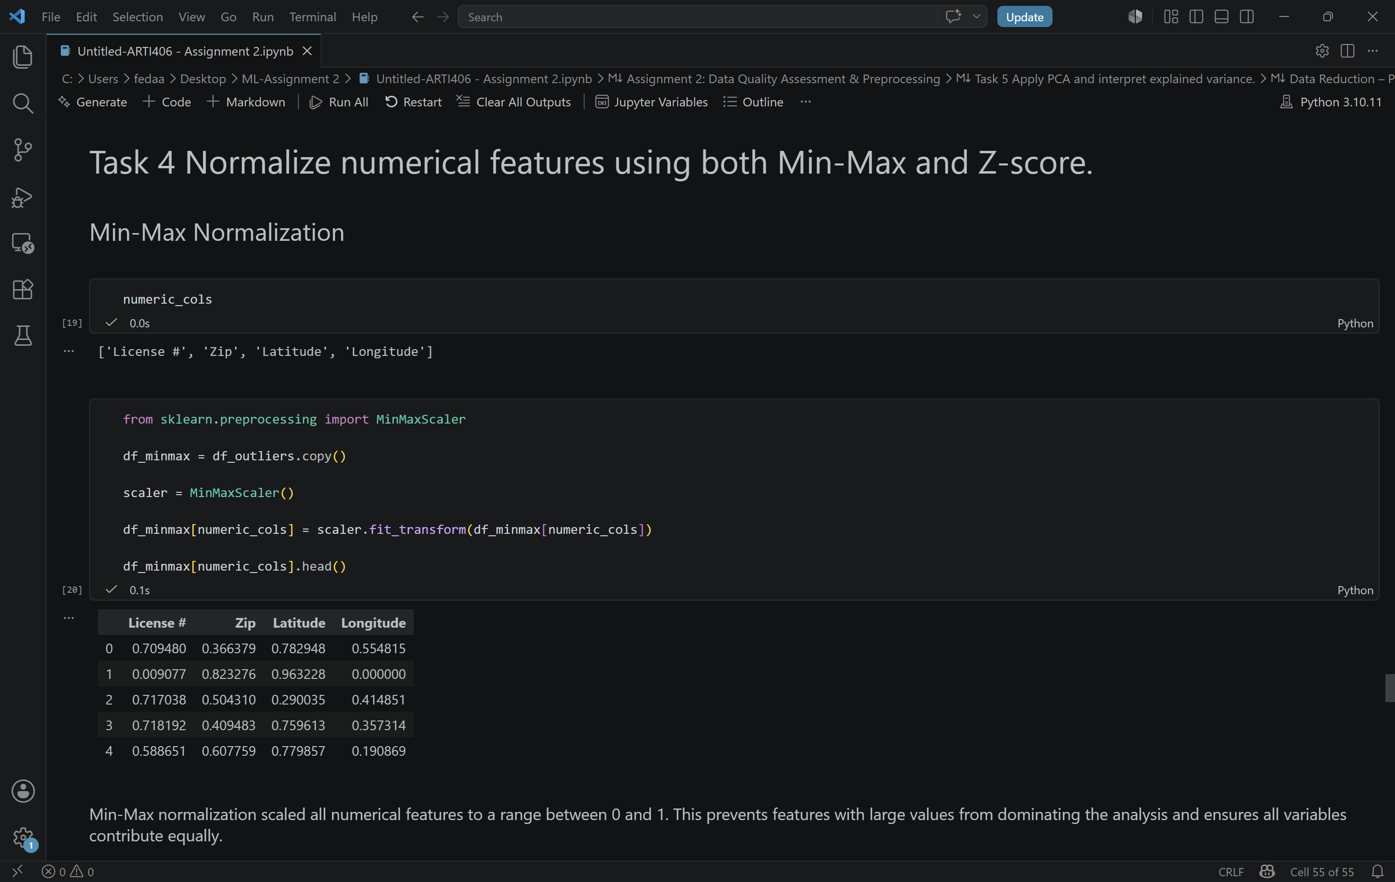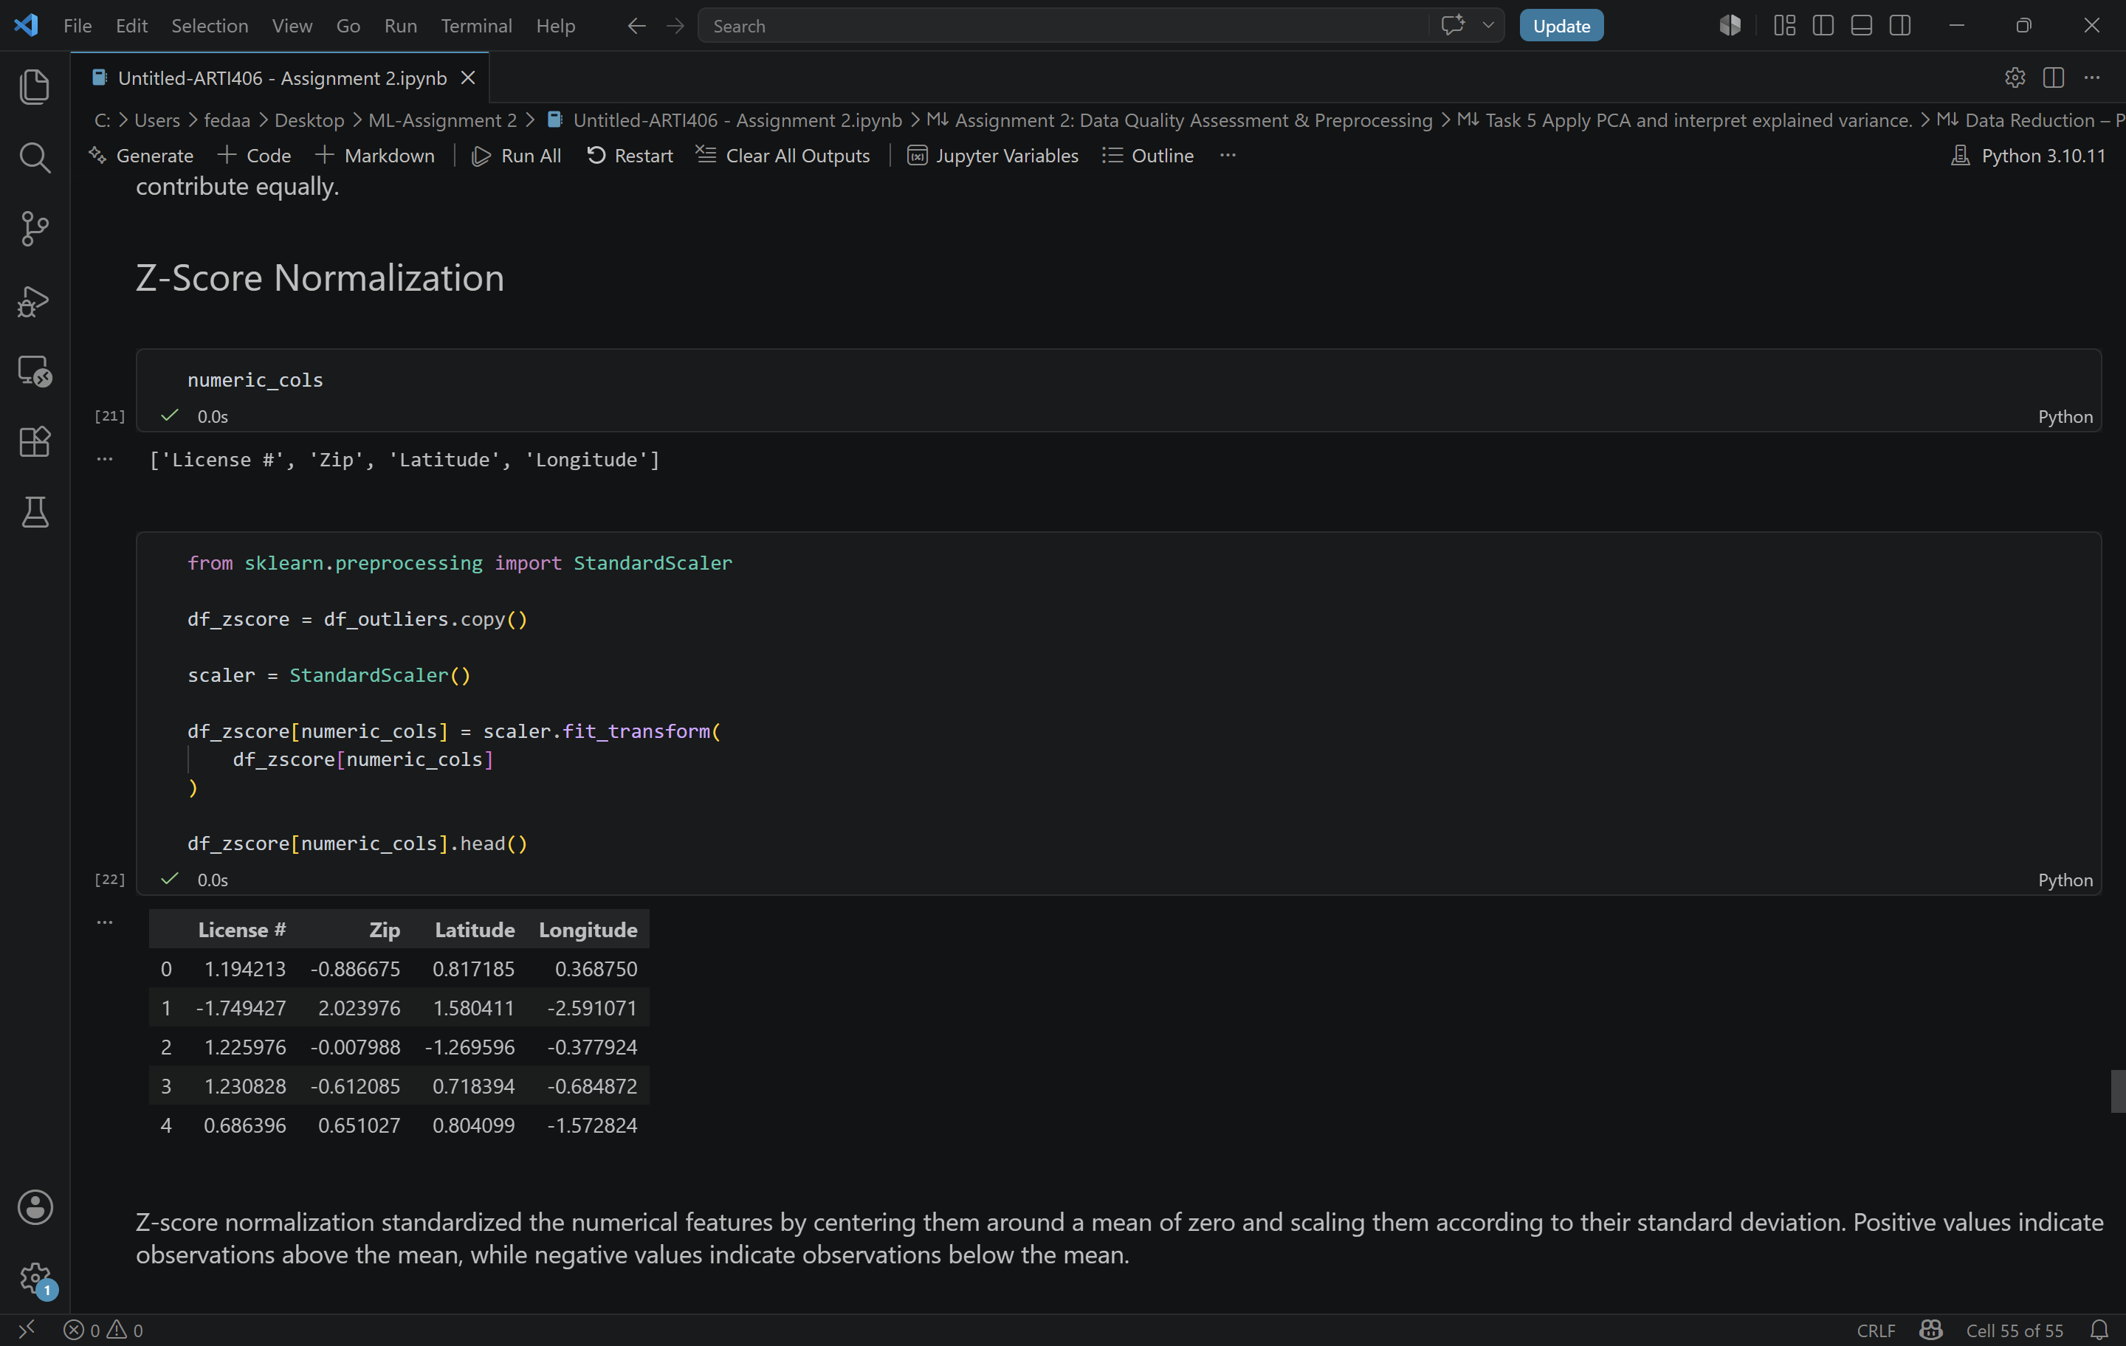

Min-Max Normalization:
Min-Max normalization was applied to the numerical features License #, Zip, Latitude, and Longitude.
This method rescales values to a range between 0 and 1 using the minimum and maximum values of each feature.
Min-Max normalization is useful when features have different scales because it prevents variables with large values from dominating the analysis.
Z-Score Normalization:
Z-score normalization was also applied to the same numerical features.
This method standardizes the data by subtracting the mean and dividing by the standard deviation.
After standardization, each feature has a mean close to 0 and a standard deviation close to 1.
Positive values indicate observations above the mean, while negative values indicate observations below the mean.
Comparison:
Min-Max normalization scales data to a fixed range between 0 and 1, while Z-score normalization standardizes data around the mean.
Min-Max is commonly used when the range of values is important, whereas Z-score is preferred for algorithms that assume normally distributed features and equal variance.

Task 5 Apply PCA and interpret explained variance:
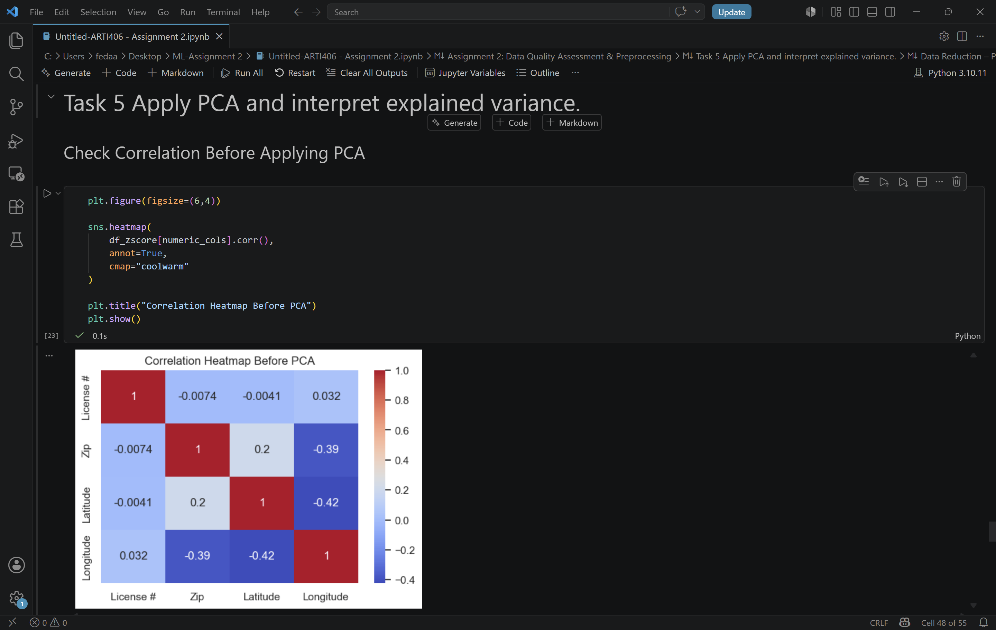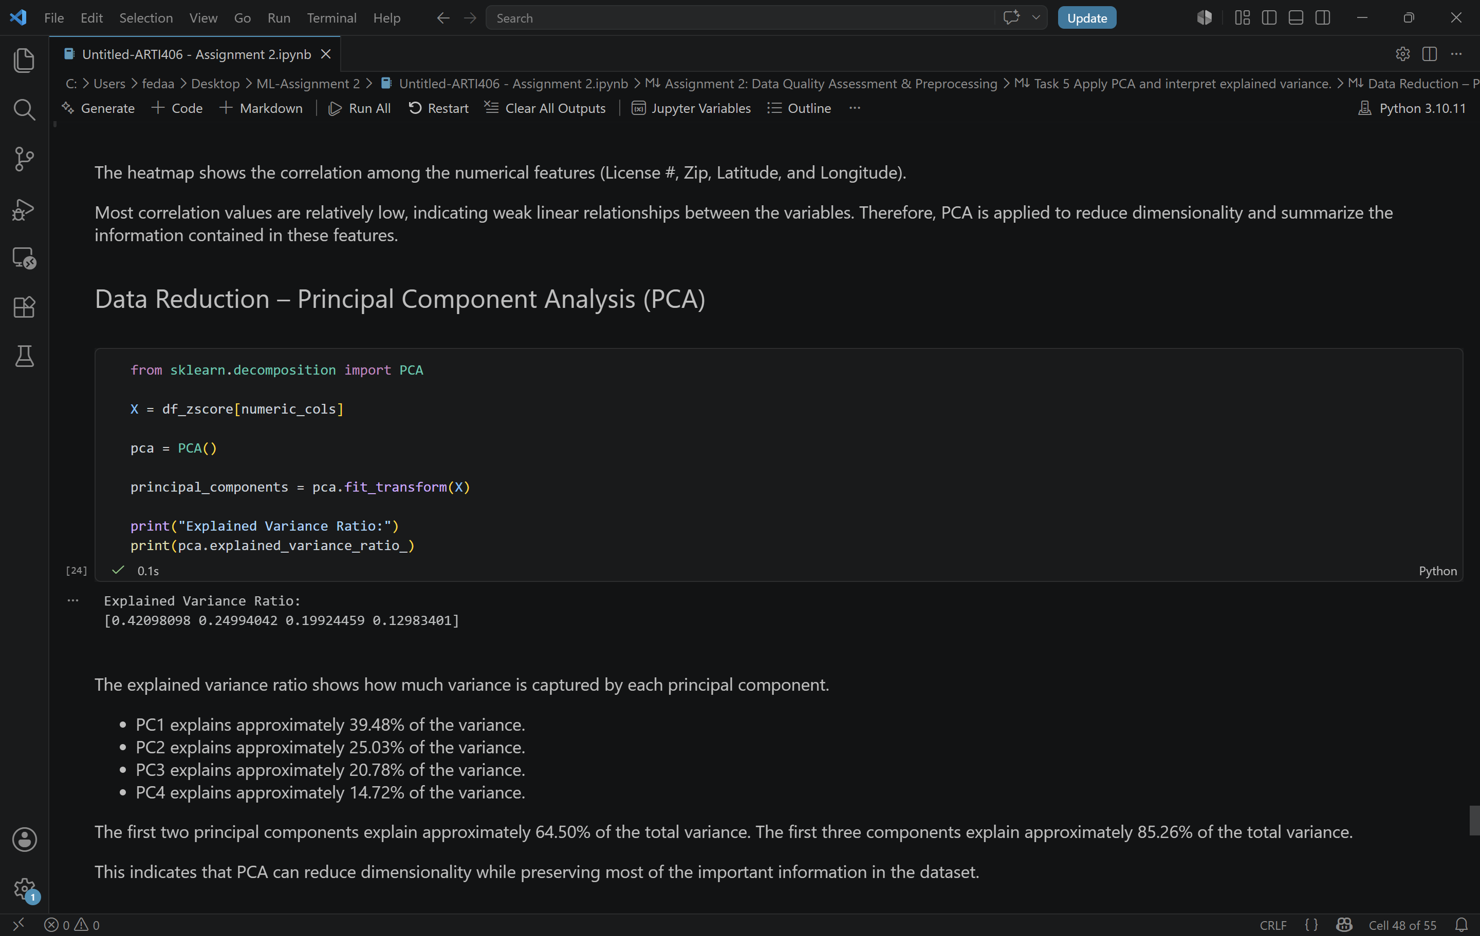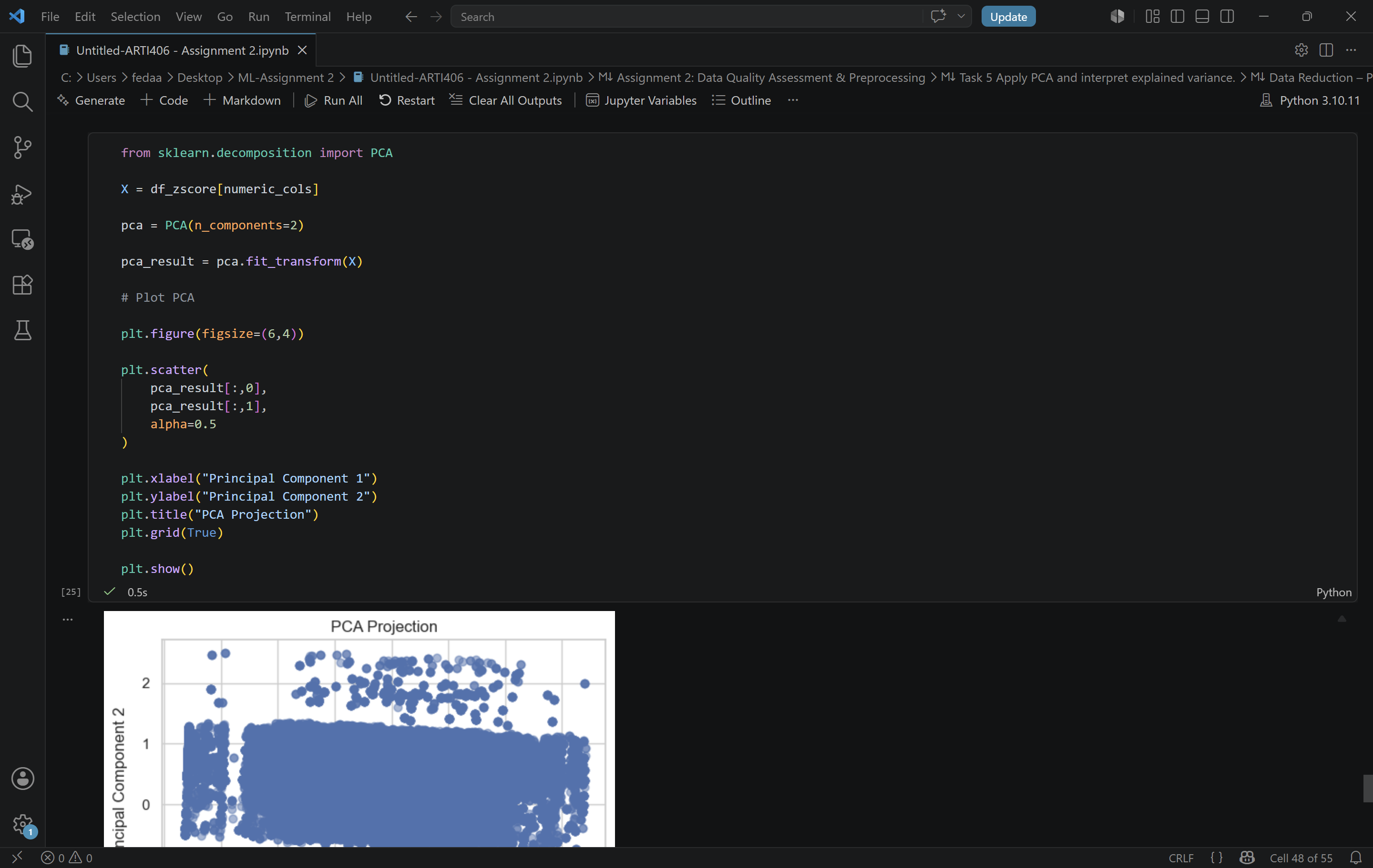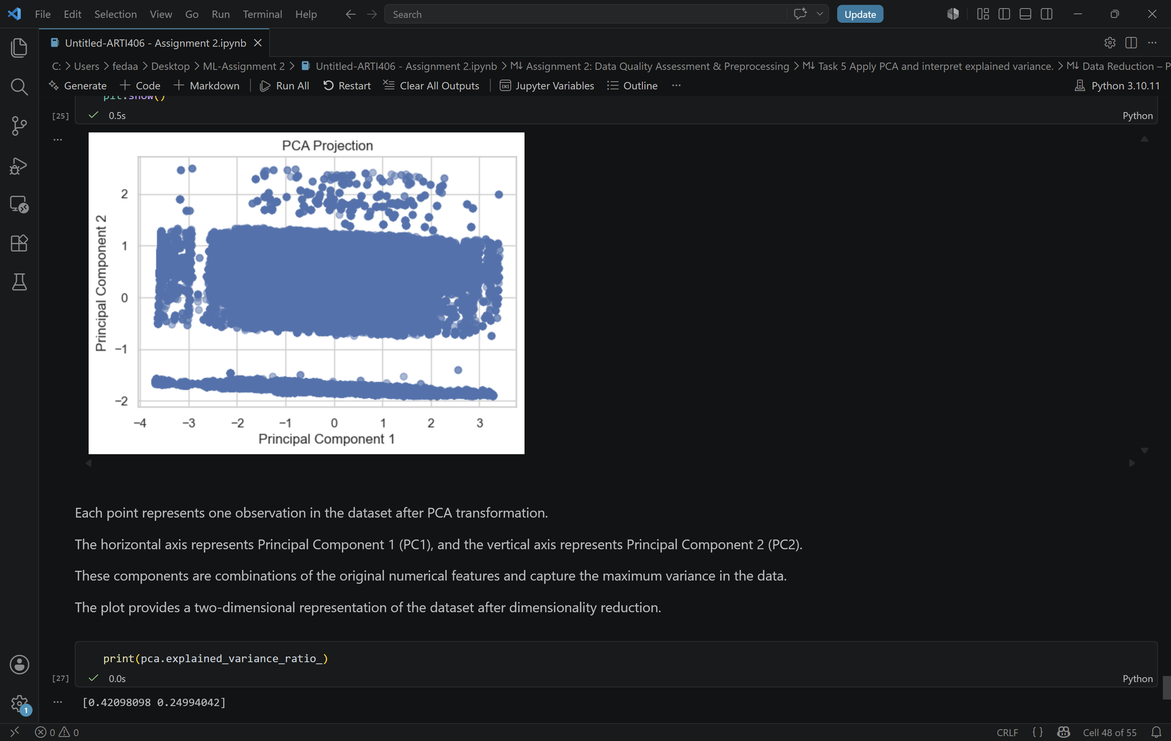

Before applying PCA, a correlation heatmap was generated to examine relationships among the numerical features.
The heatmap shows that most correlations are relatively weak, indicating limited linear relationships between variables. Therefore, PCA can be used to summarize the information contained in these features and reduce dimensionality.
The explained variance ratio indicates the amount of information captured by each principal component.
PC1 explains approximately 42.10% of the total variance.
PC2 explains approximately 24.99% of the total variance.
PC3 explains approximately 19.92% of the total variance.
PC4 explains approximately 12.98% of the total variance.
The first two principal components together explain approximately 67.09% of the total variance, while all four components explain 100% of the variance.

The PCA projection visualizes the dataset using the first two principal components.
Each point represents one observation after dimensionality reduction. The horizontal axis corresponds to Principal Component 1 (PC1), while the vertical axis corresponds to Principal Component 2 (PC2).
The plot provides a two-dimensional representation of the dataset while preserving most of the important information captured by the original numerical features.

PCA successfully reduced the dimensionality of the dataset while retaining most of the important information. The first two principal components captured approximately 67.09% of the total variance, making them suitable for representing the dataset in a lower-dimensional space.

